
Internet of things project

Independent Growth Greenhouse
TONY LEONARD
Bachelor of Software and Electronic Engineering Galway-Mayo Institute of Technology

2019/2020

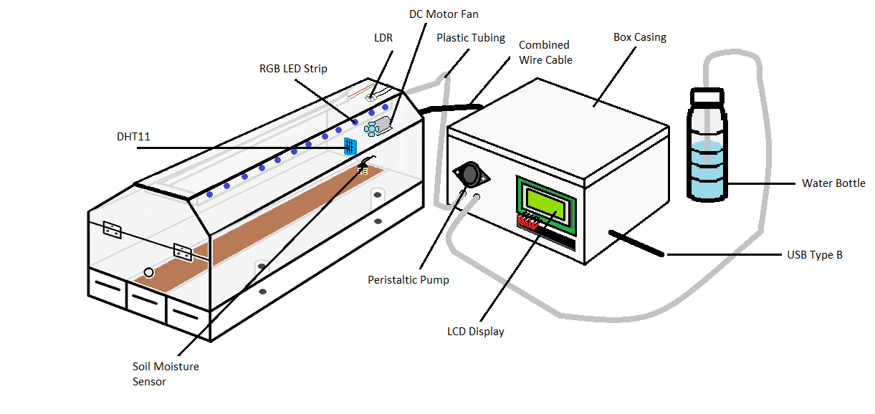
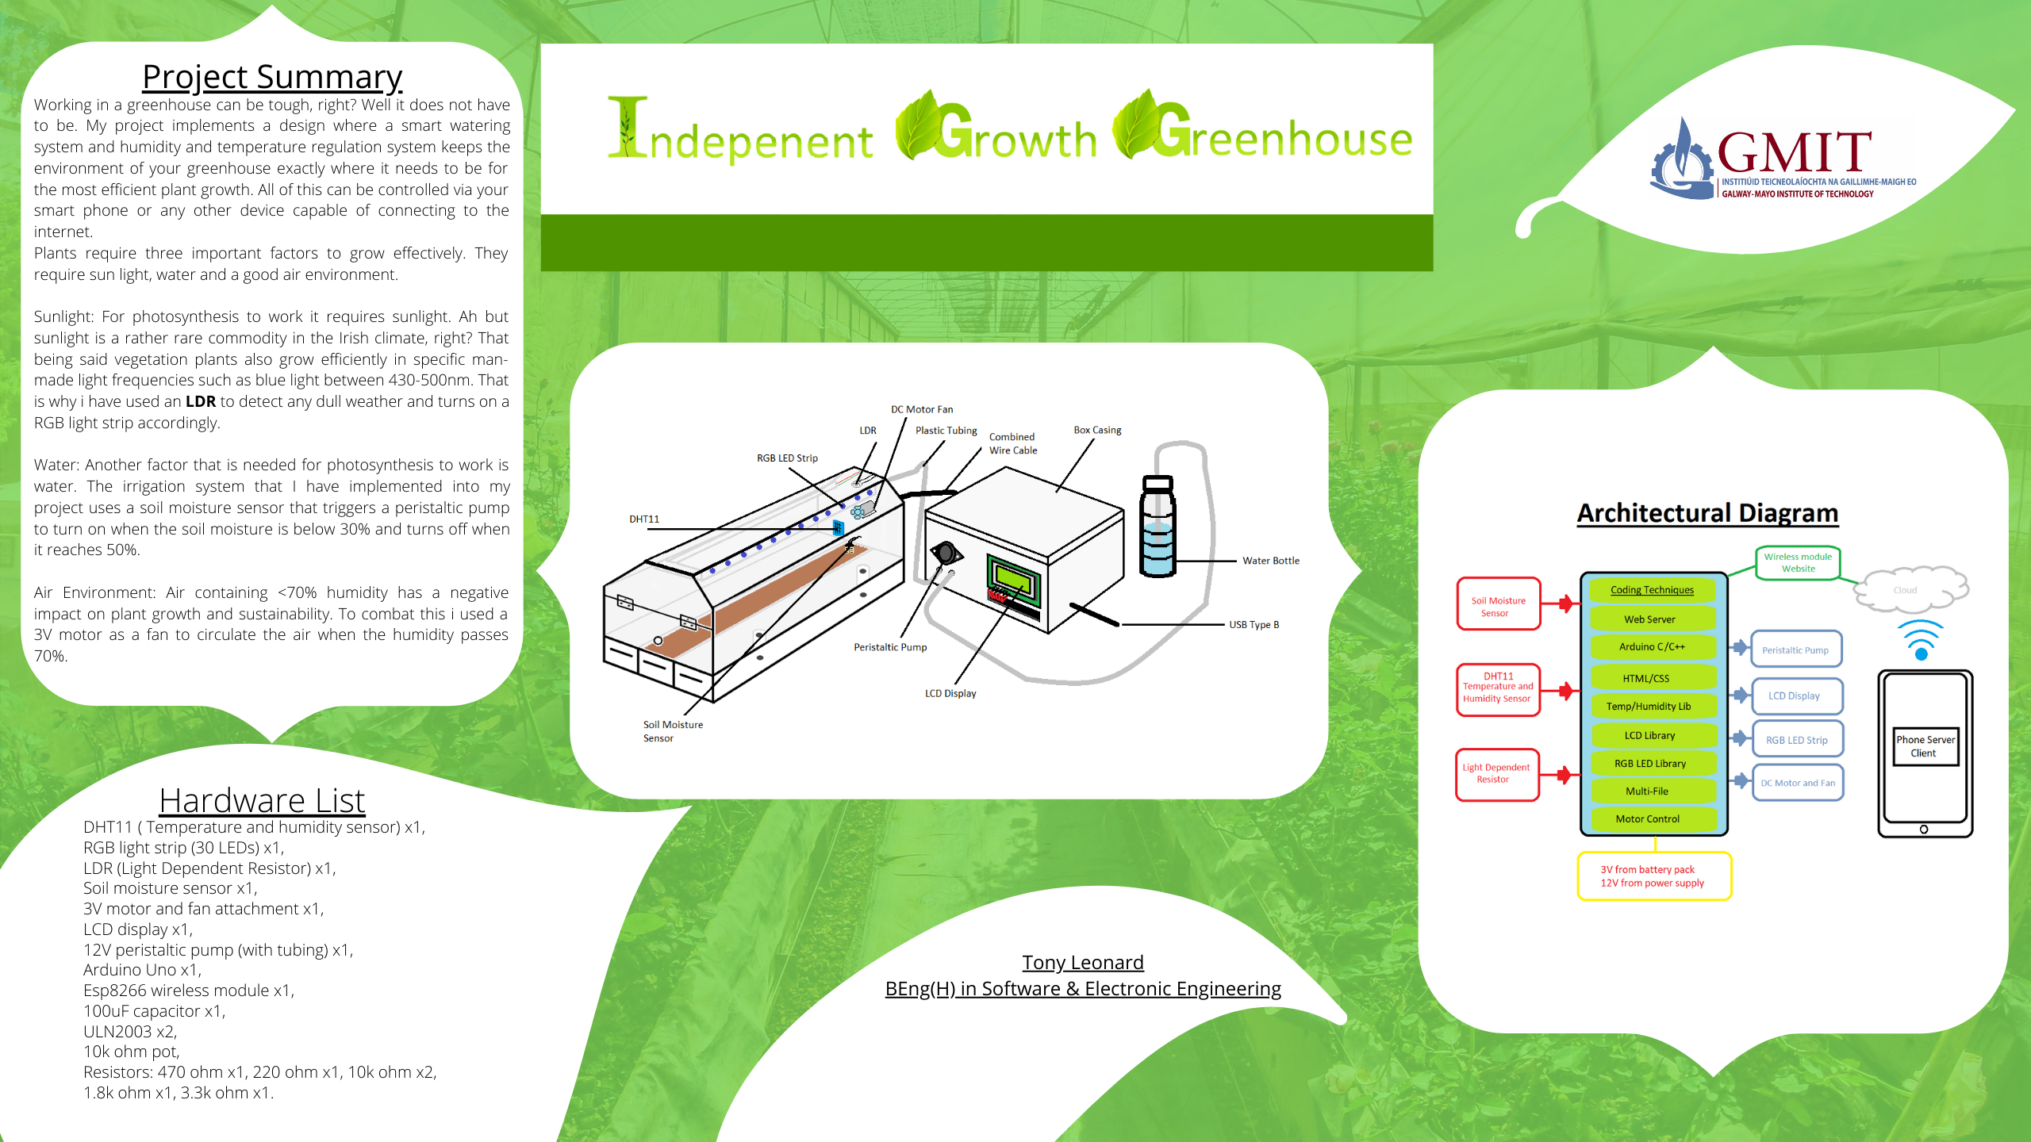
Poster
Declaration
This project is presented in partial fulfilment of the requirements for the degree of Bachelor of Engineering in Software & Electronic Engineering at Galway-Mayo Institute of Technology. This project is my own work, except where otherwise accredited. Where the work of others has been used or incorporated during this project, this is acknowledged and referenced.

Acknowledgements
I would like to thank my Leaving Certificate Technology teacher Michael Jackson for allowing me to use the physical build of the greenhouse for my IoT project.
I would also like to thank my IoT lecturers Natasha Rohan and Brian O’Shea for guiding and aiding me in the development of my project.
Finally, I would also like to thank my parents for giving me constant support throughout the academic year. They also provided me with any other auxiliary materials I needed without a second thought.
To all these people thank you very much.

Project Summary
Working in a greenhouse can be tough, right? Well it does not have to be. This project implements a design where a smart watering system and humidity and temperature regulation system keeps the environment of your greenhouse exactly where it needs to be for the most efficient plant growth. All of this can be controlled via your smart phone or any other device capable of connecting to the internet.
Plants require three important factors to grow effectively. They require sun light, water and a good air environment.
Sunlight: For photosynthesis to work it requires sunlight. Ah but sunlight is a rather rare commodity in the Irish climate, right? Vegetation plants also grow efficiently in specific man-made light frequencies such as blue light between 430-500nm. That is why I have used an LDR to detect any dull weather and turns on the RGB light strip accordingly.
Water: Another factor that is needed for photosynthesis to work is water. The irrigation system that is implemented into the project uses a soil moisture sensor that triggers a peristaltic pump to turn on when the soil moisture is below 30% and turns off when it reaches 50%.
Air Environment: Air containing <70% humidity has a negative impact on plant growth and sustainability. To combat this, a 3V motor used as a fan circulates the air when the humidity passes 70%.

Table of Contents
1 Introduction 9
1.1Project-Goals 9
1.2 Project-Motivation 9
1.3 About Independent Growth Greenhouse 9
2 Project Plan 10
3 Architectural Block Diagram 11
4 Sensors 12
4.1 LDR (Light Dependent Resistor) 12
4.2 DHT11 13
4.3 Soil Moisture Sensor 13
5 Motors 14
5.1 DC Motor (3V) 14
5.2 Peristaltic Pump (12V) 14
6 Liquid Crystal Display (LCD) 15
7 RGB Strip 15
8 Web Server 16
8.1 ESP8266 & Wi-Fi 16
8.2 Web Server 16
9 Circuit Diagrams 17
10 Problems Solved 19
11 Conclusions 20
12 References 21
13 Appendices 22
13.1 Logbook 22
13.2 Code 24
13.3 PCB & Schematic 30
13.4 Bill of Materials 31
13.5 Final Pictures of Project 32
13.6 Drawings of Manufacture 34

1.Introduction
1.1Project-Goals
The goals I have set for my project are that my work is at a professional level, my deadlines are met with good timing and the aesthetic of my project meet my usual quality of craftmanship.
1.2 Project-Motivation
I started designing my project when I was in Leaving Cert Technology as we were given a brief to design a project around the production or process of food and edible products. I achieved a good grade in technology, but I was never satisfied with the electronic side of my project.
My motivation blossomed when I decided to rethink and rework my old project using the new skills, I have learned throughout my time in college to produce a far better project and fulfil my goal to truly create an Independent Growth Greenhouse.
1.3 About Independent Growth Greenhouse
The project uses a range of electronic components and sensors to allow the user to maintain and irrigate a greenhouse without requiring the user to manually check on the greenhouse. It uses a webserver to allow the user to check the temperature, humidity and soil moisture in the greenhouse and automatically waters the plants when the soil moisture goes below 30%. A fan turns on if the humidity exceeds 70%. A blue RGB strips activates if the day is dull and the greenhouse is not getting enough sunlight.
2.Project Plan
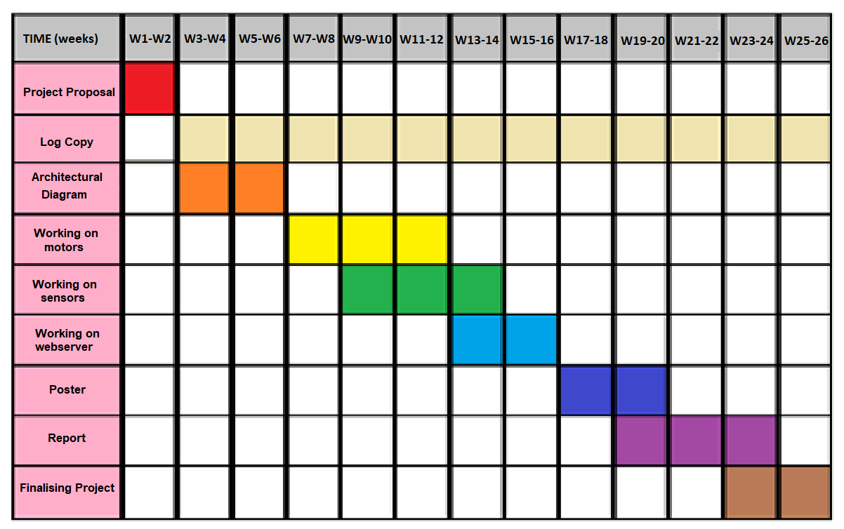
This Gant chart is influenced by the deadlines the lecturers have given and gives a general view of how the time was managed when it comes to meeting deadlines and completing the IoT project.
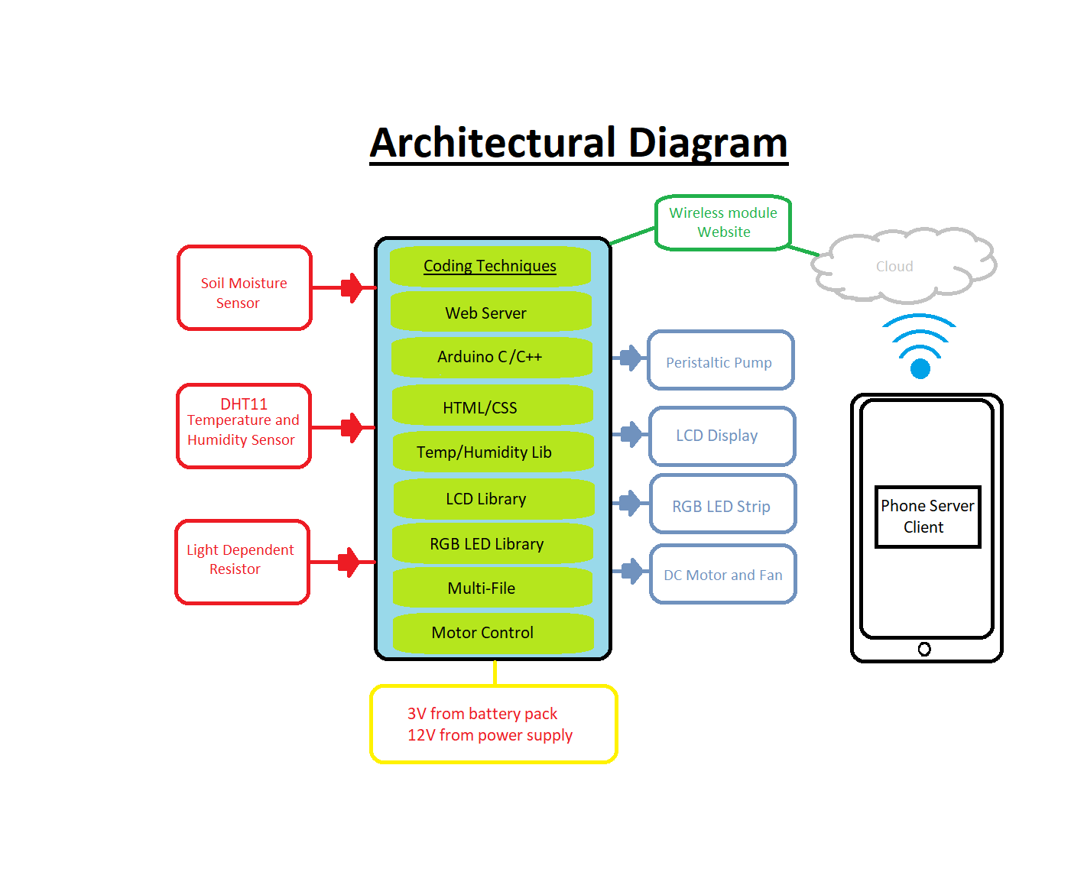
3.Architecture Block Diagram

4.Sensors
The sensors in the project act as all the inputs, sending the data they collect through the code to the outputs.
4.1 LDR (Light Dependent Resistor)
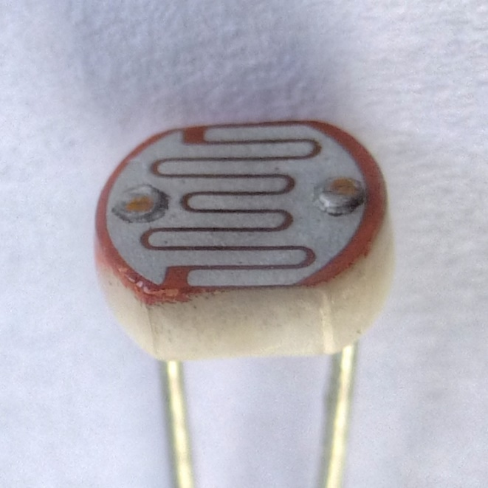
The LDR’s function in the project is to detect whether the day is dull or sunny. If the day is dull the LDR will then trigger the RGB strip to turn on (more info on that in the RGB section of the report). On the other hand, if the LDR detects that it is sunny or there is very little light shining on it, it means that the RGB strip will not turn on whatsoever. This is because the code has been set that the RGB strip will only turn on if the day is dull and not for a sunny day or night situation. The LDR connects via the PCB in the project and the circuit can be seen in the circuit diagram section of the report. There are pictures of the LDR’s placement as well as all the other components in the appendices as well as placing arrangement for the PCB.

4.2 DHT11

The DHT11’s role is to measure the temperature and humidity in the greenhouse. If the humidity exceeds 70% the 3V DC motor will turn on and circulate the air until the humidity is at 70% again. The optimum humidity for vegetative green plants is 70% humidity and the DHT11’s purpose is to keep it around that percentage. The DHt11 is connected to the Arduino via the PCB.
4.3 Soil Moisture Sensor
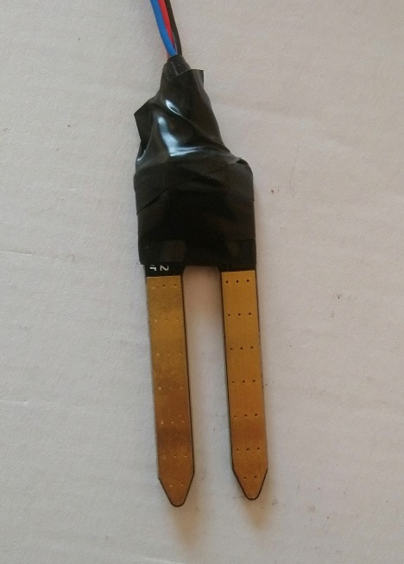
The Soil moisture sensor as the name of it suggests, measures the moisture content in the soil. After some research done the appropriate moisture content in the soil should be between 30% and 50%. If it is greater than 50% there is a risk of the soil becoming water-logged and if its below 30% its too dry. The best thing to do is to keep it in between the two and that’s what the soil moistures sensor’s purpose is. The sensor sends a signal to the pump when the moisture content is below 30% and turns off the pump if it reaches past 50% giving the plants enough water to grow efficiently.

5. Motors
The motors act as an output and receive data from the sensors. There are two motors a 3V DC motor (fan) and a 12V DC Motor (pump).
5.1 DC Motor (3V)
The 3V DC Motor is used in the green house as a fan. A fan attachment goes on the front of the motor. The purpose of the motor is to circulate the air when the DHT11 sends the signal that the humidity has exceeded 70%.
5.2 Peristaltic Pump (12V)
The peristaltic pump is used to pump water through the irrigation system in the greenhouse. The soil moisture sensor sends a signal to the pump when the moisture content drops below 30% and turns off the pump when it reaches 50%.
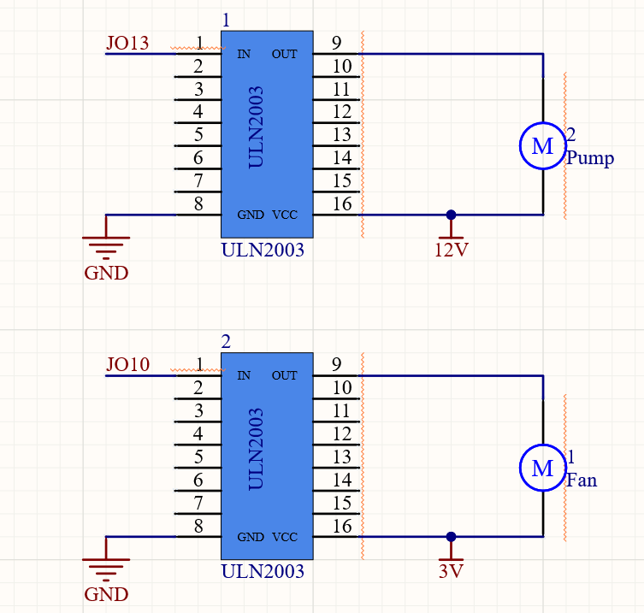

6. Liquid Crystal Display (LCD)
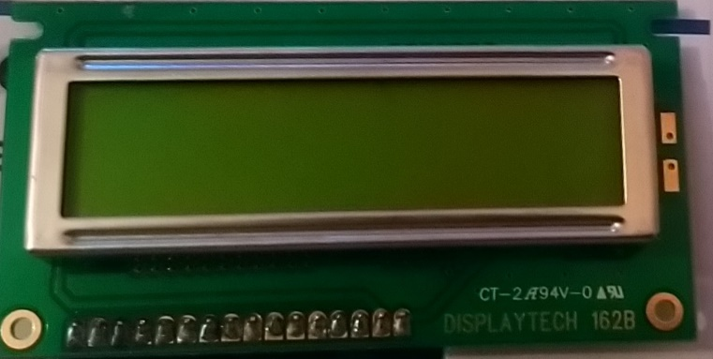
The LCD is used to display all the data the sensors collect which include the temperature, humidity and soil moisture content. It displays the temperature in degrees Celsius and shows both the humidity and soil moisture in percentage form.
7. RGB Strip
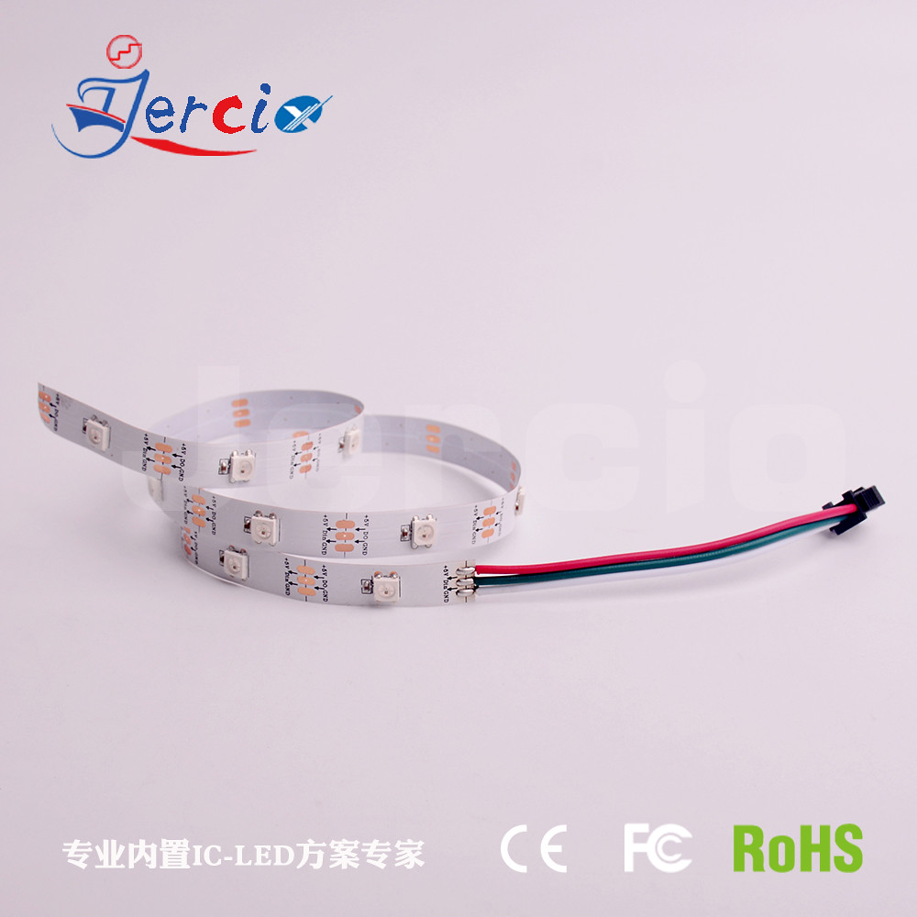
The RGB strip is used to simulate a blue grow light which is a sunlight substitute to aid the growing process of leafy greens. The LDR on top of the greenhouse detects the correct amount of light the plants need to grow efficiently. If the LDR is getting a small amount of light (dull day), it will turn on the RGB strip which shines in a blue light. If the LDR detects a large amount of light (sunny day) the RGB strip will not turn on at all, this is the same if the LDR detects no light (night-time) at all either. Plants need time to rest and that is why the RGB does not turn on if it is not getting any light at all.

8. Web Server
8.1 ESP8266 & Wi-Fi
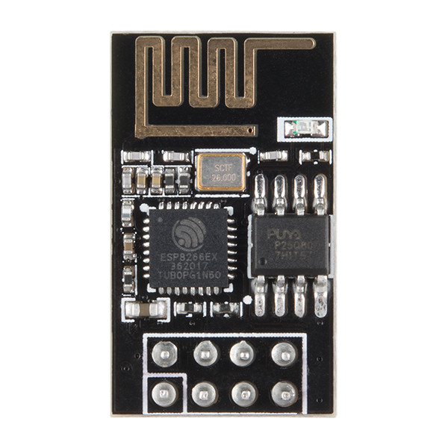
The wireless hotspot on the phone is how the ESP8266 hosts the web server. The phone is a Sony Xperia XA2. The name of the wireless hotspot is; 5GGG and the password is; 12345678. The ESP8266 is connected to the Arduino Uno via a stripboard.
8.2 Web Server
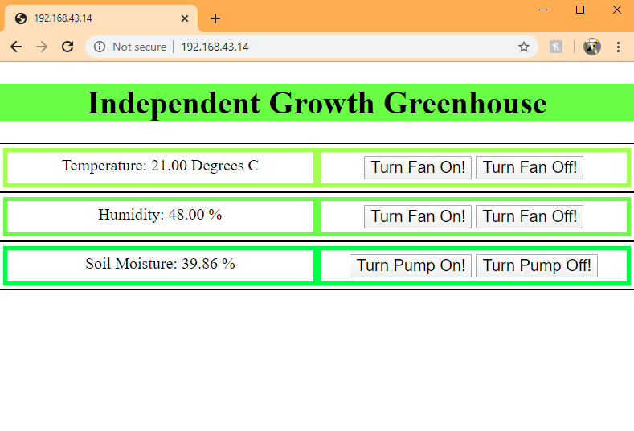
The Web Server is a basic looking webpage that consists of HTML/CSS. It contains three different shades of green for the inner borders and black for the outer border. It displays the temperature, humidity and soil moisture and a user can remotely turn on and off the fan and pump at any time. There is a title at the top of the page showing the name of the project.
9.Circuit Diagrams
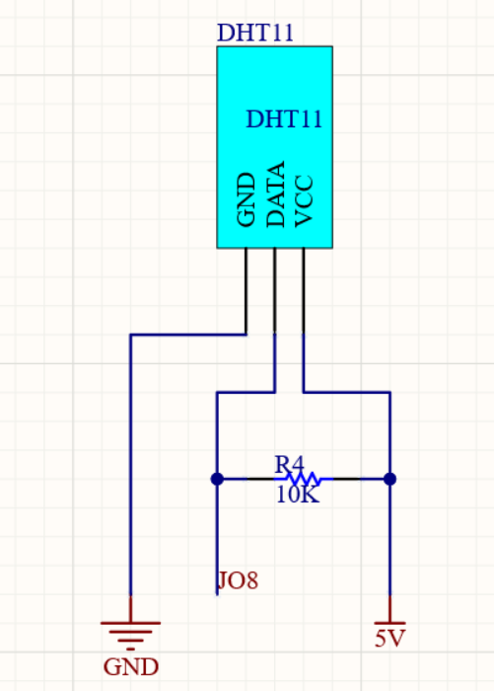
DHT11 Diagram
The DHT11’s data pin is connected to pin 8 on the Arduino Uno. VCC is connected to 5V and GND is connected to GND. The DHT11 is connected to the Arduino via the PCB design.
Soil Moisture Sensor Diagram
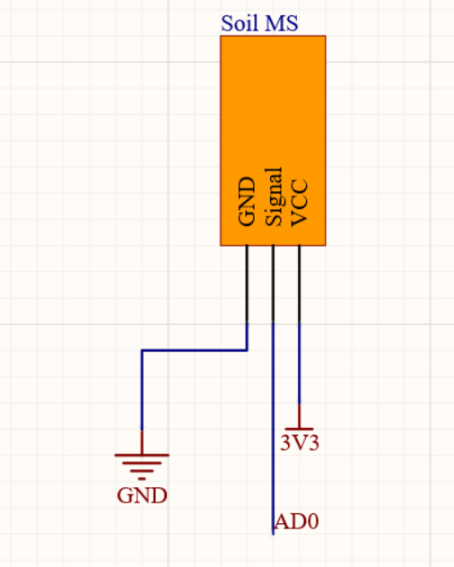
The soil moisture sensor’s signal pin is connected to pin A0 on the Arduino Uno. VCC is connected to 3.3V and again GND is connected to GND. The soil MS is also on the PCB design.
RGB Strip Diagram
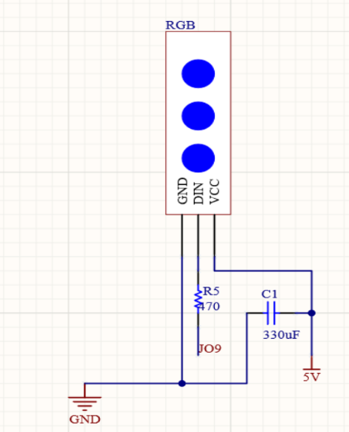
The RGB’s data pin is connected to pin 9 on the Arduino. It uses 5V to power it and is also connected to the Arduino Uno via the PCB.

LDR (Light Dependent Resistor) Diagram
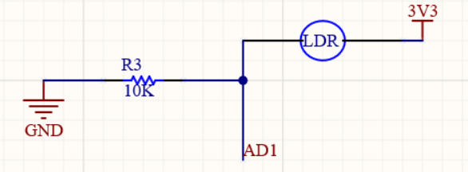
The LDR is connected to pin A1 on the Arduino Uno and is powered by 3.3V. This is the last working component that is connected to the Arduino via the PCB.
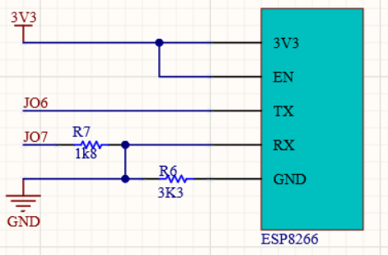
ESP8266 Diagram
The ESP8266 is connected to pin 6 and pin 7 on the Arduino and is powered by 3.3V. The ESP8266 is connected to the Arduino via a strip board circuit.
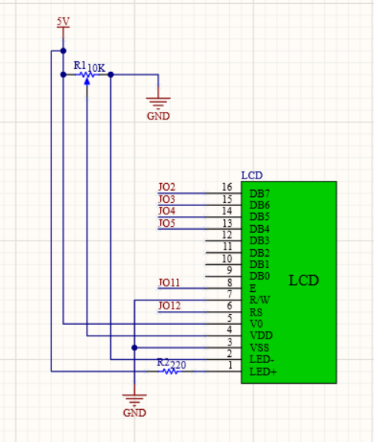
LCD Diagram
The LCD is connected to pins; 2, 3, 4, 5, 11 and 12. The LCD is powered by 5V and is also connected to the Arduino Uno via a stripboard circuit.

10.Problems Solved
1.) The first problem I encountered was an issue I had with the PCB I designed myself. The situation was that I mistakenly routed a wrong Net-label while I was designing the PCB on Altium, this meant that both the LCD and ESP8266 were inoperable while there were connected to the PCB. Luckily none of the other Net-labels were affected by this mistake which meant that all my sensors and my RGB strip were routed correctly. At first, I believed that I had overheated both the LCD and ESP8266 but thankfully that was not the case.
The solution to this problem was that I created two stripboard circuits to connect both the LCD and ESP8266 to the Arduino Uno whilst keeping the build aesthetically pleasing.
2.) The second problem was quite an obvious one, in which probably no student has ever encountered prior to this year was the Covid-19 outbreak. The problem was that all my physical materials for my project were left in my locker which is in the Galway Campus.
Luckily a kind soul in GMIT allowed me to receive my project and was able to get all my materials from my locker. I also had to purchase some materials online as we were not able to access any of the other resources in the labs located in GMIT.

11.Conclusion
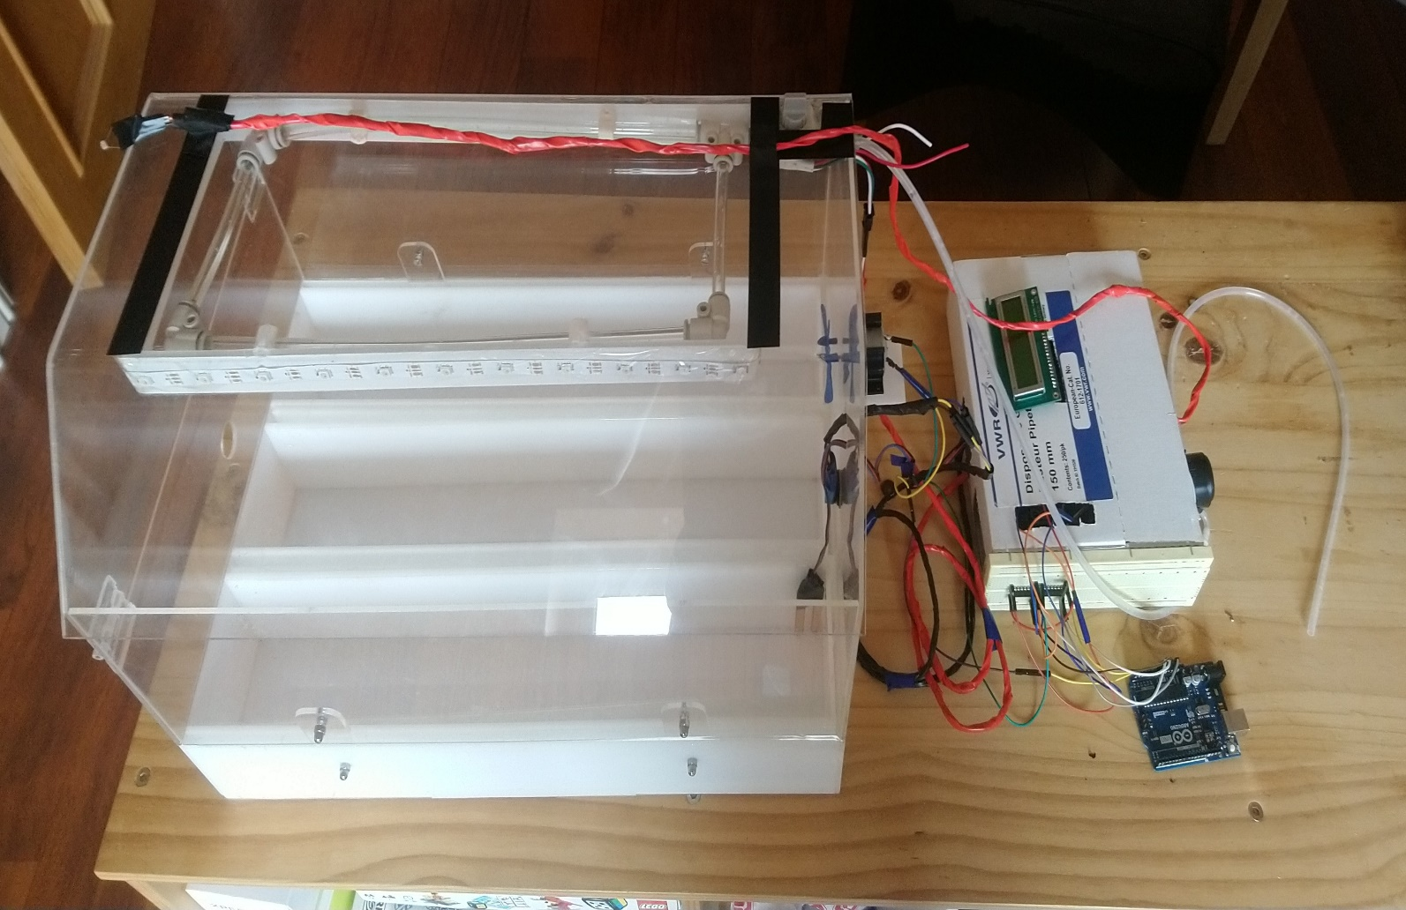
I reminisce when I first started the greenhouse project in my Leaving Certificate year. At that time, I would not have even dreamth to come this far, but here I am. The entirety of the project is done to the best of my ability. The Independent Growth Greenhouse does as the name suggests and I strongly believe it could be made into a commercially sold product given time. All the sensors in my project work and gather the correct data to the best of my knowledge, the outputs work according to plan as well. This project has been a learning curve from the start and the new skills I have learned will surely help me in the years to come.
12.References
I used four libraries for the Arduino components, these include:
Adafruit NeoPixel Library; https://travis-ci.com/adafruit/Adafruit_NeoPixel
DHT11 Library; Rob Tillaart; http://arduino.cc/playground/Main/DHTLib
WiFiESP Library; bportaluri; https://github.com/bportaluri/WiFiEsp
Liquid Crystal Library; Adafruit; https://www.arduino.cc/en/Reference/LiquidCrystal

I used these websites to learn how to connect components:
https://www.circuitbasics.com/how-to-set-up-the-dht11-humidity-sensor-on-an-arduino/ (DHT11 & LCD pg. 17+18)
https://learn.adafruit.com/assets/30892 (RGB Strip pg. 17)
https://create.arduino.cc/projecthub/electropeak/complete-guide-to-use-soil-moisture-sensor-w-examples-756b1f (Soil Moisture Sensor pg. 17)

I used Canva (graphical design app) to help create a poster:
https://www.canva.com/ (pg. 3)

I used some Google images with usage rights of “Free to use, share or modify, even commercially”:
https://commons.wikimedia.org/wiki/File:LDR_1480405_6_7_HDR_Enhancer_1.jpg (LDR pg. 12)
https://www.flickr.com/photos/146896161@N07/38409276131 (RGB pg. 15)
https://freesvg.org/temperature-and-humidity-sensor (DHT11 pg. 13)
https://www.flickr.com/photos/sparkfun/37816619545 (ESP8266 pg. 16)
I used Altium to design a PCB.

13.Appendices
13.1 Logbook
Here are some pictures from the logbook that have been added since the last assessment of the logbook:
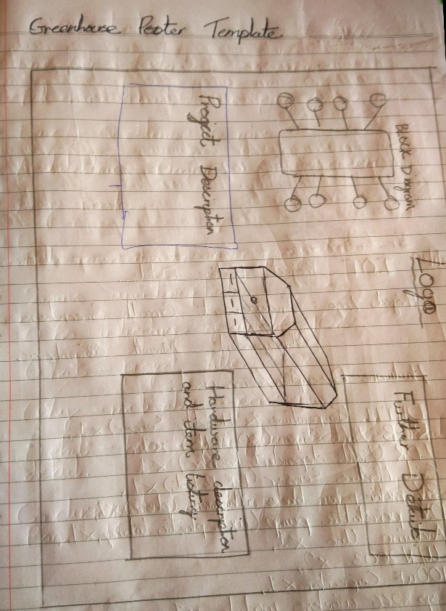
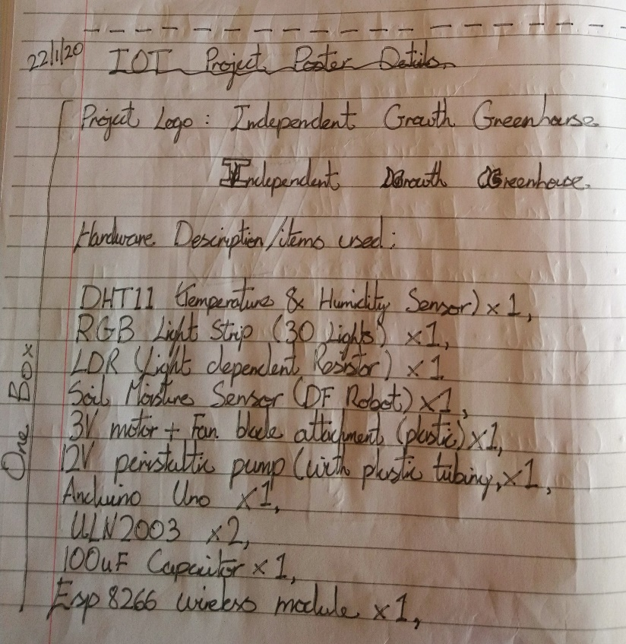

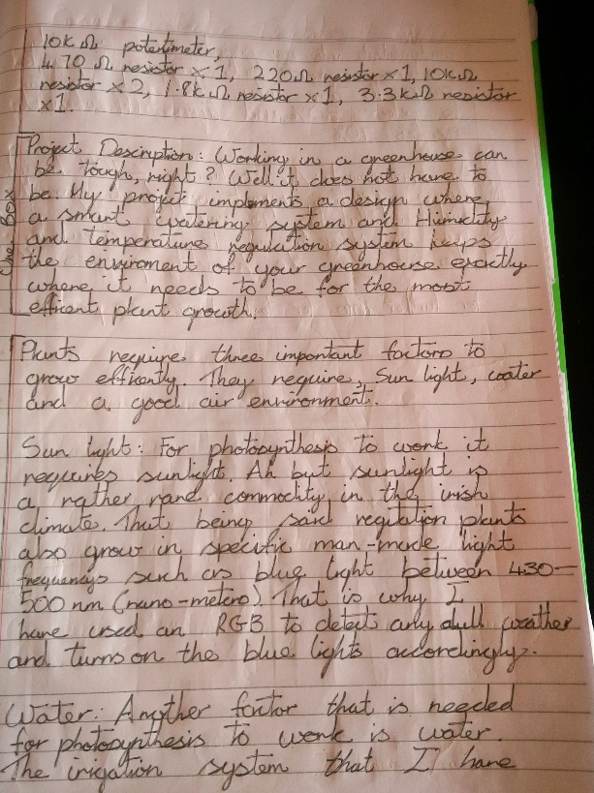
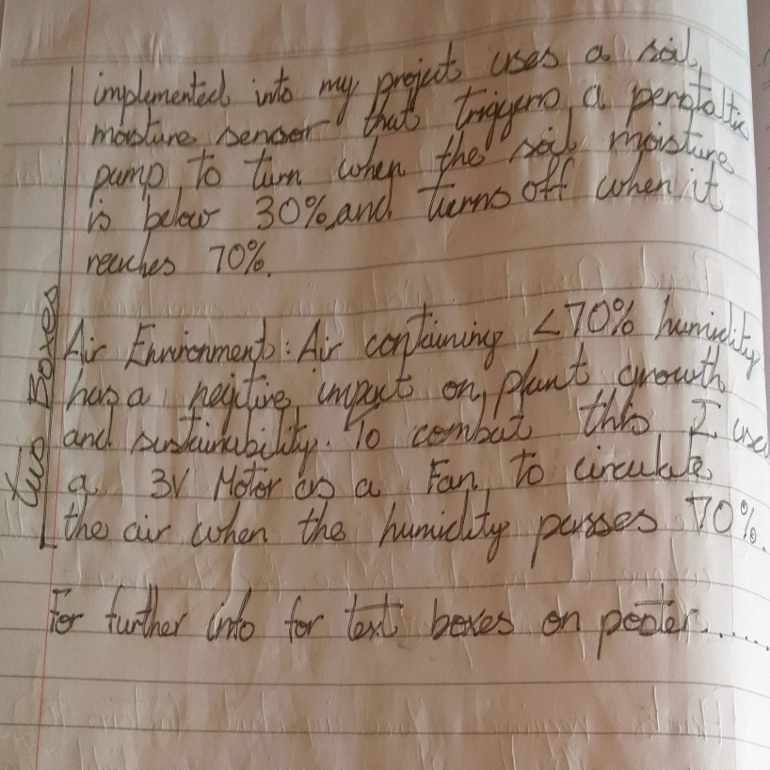

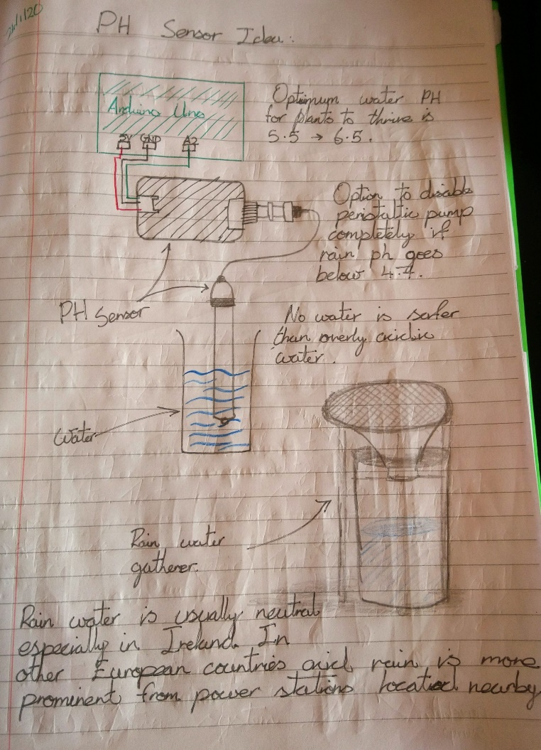
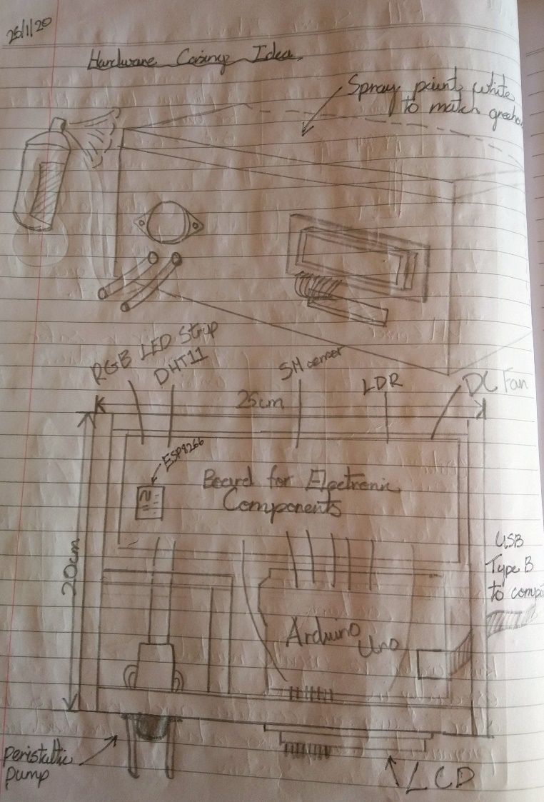
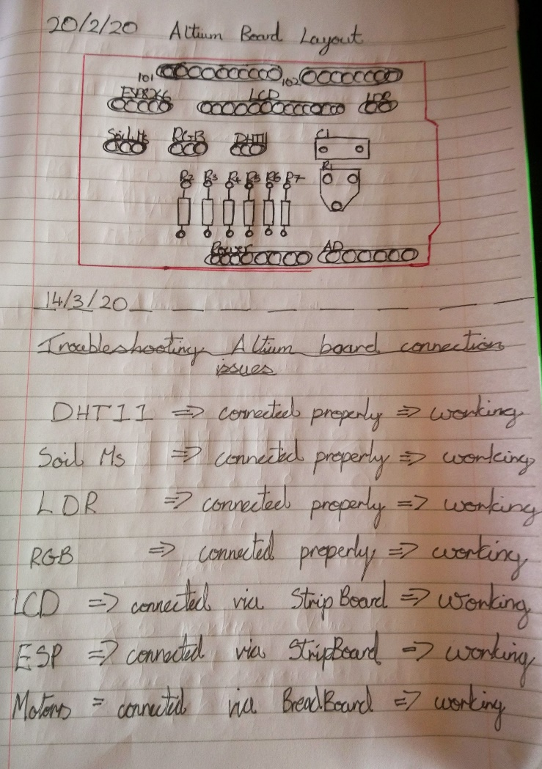
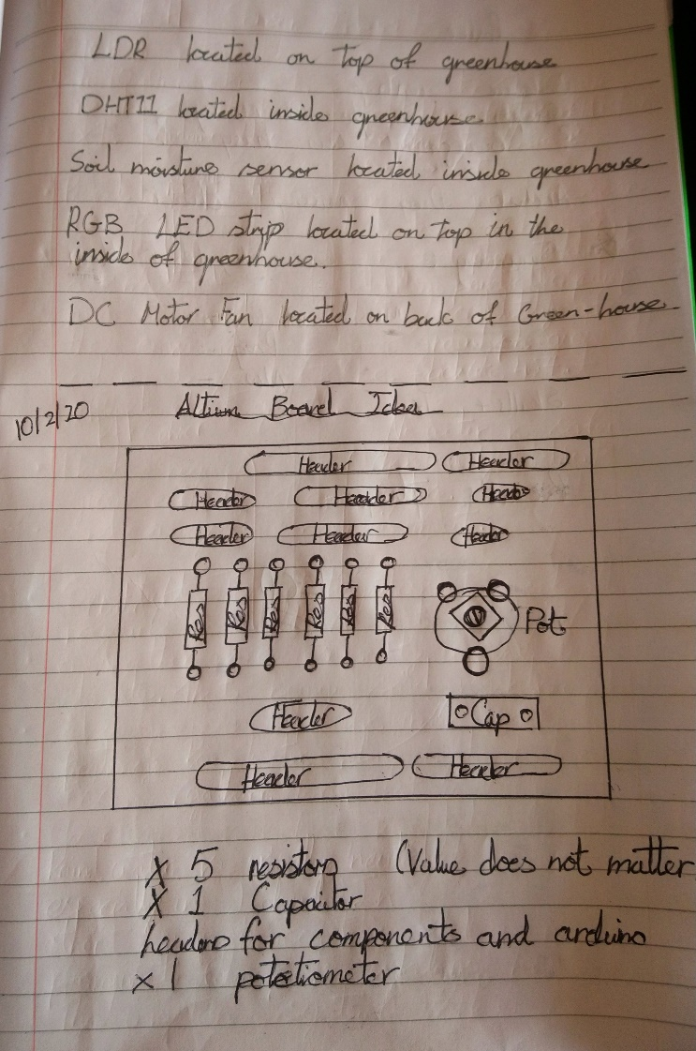
13.2 Code
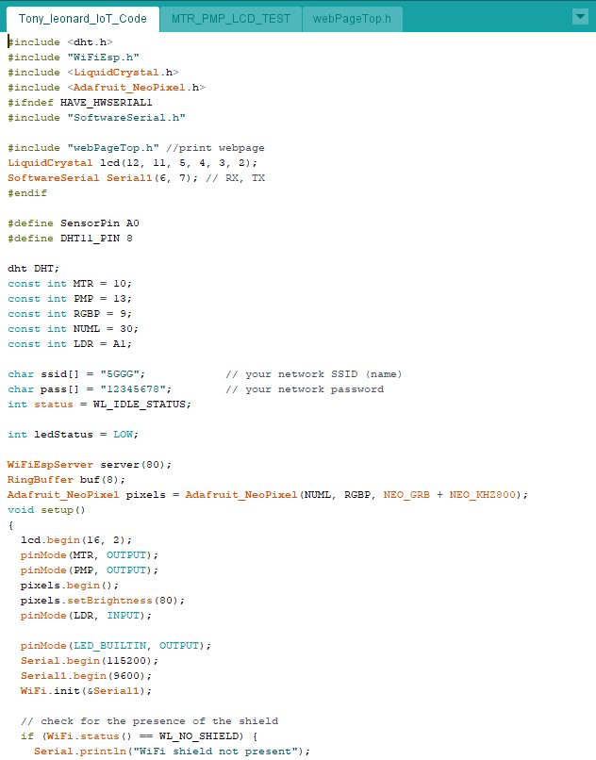
Here are the screenshots of the final code which operates the electronic components:
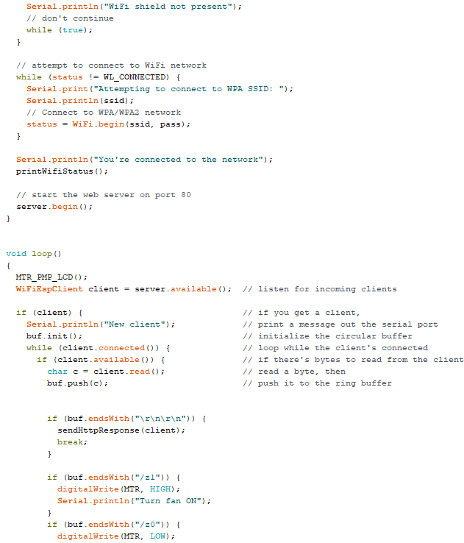

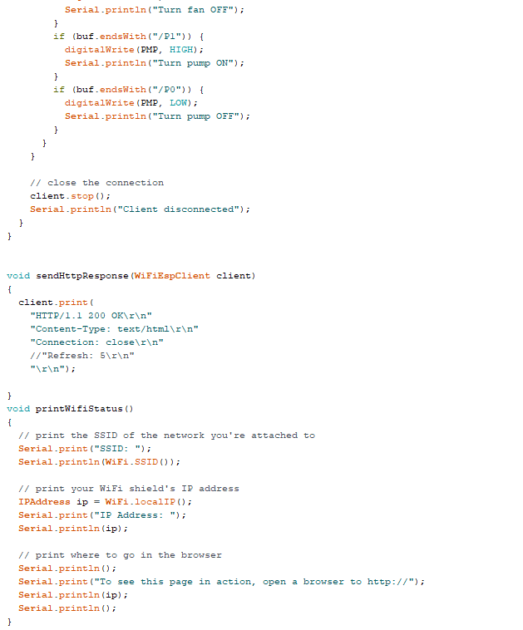

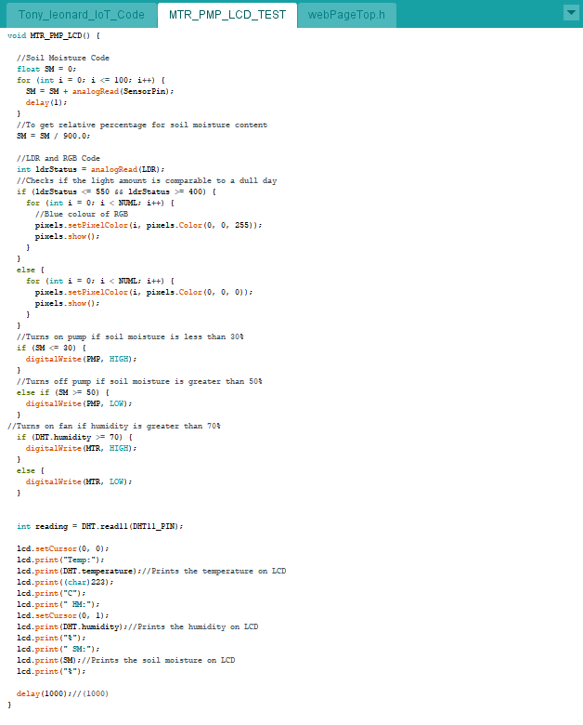
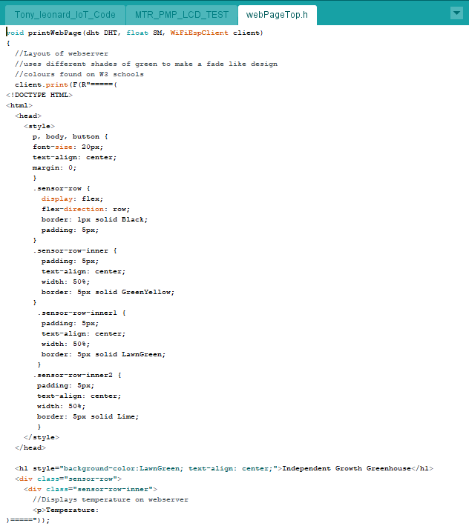
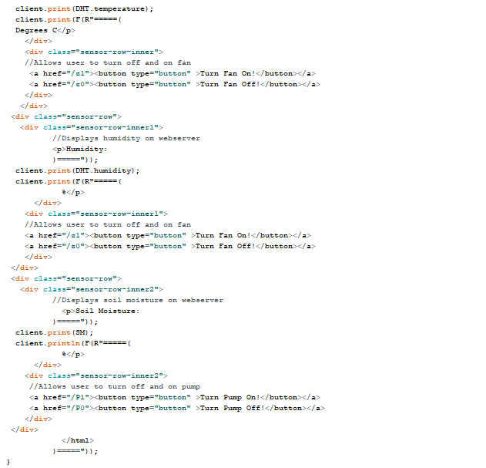
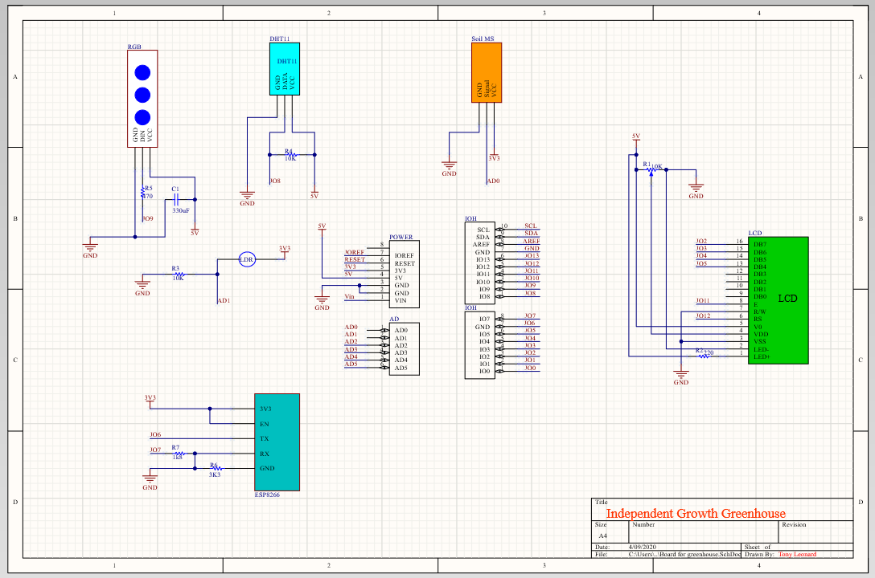
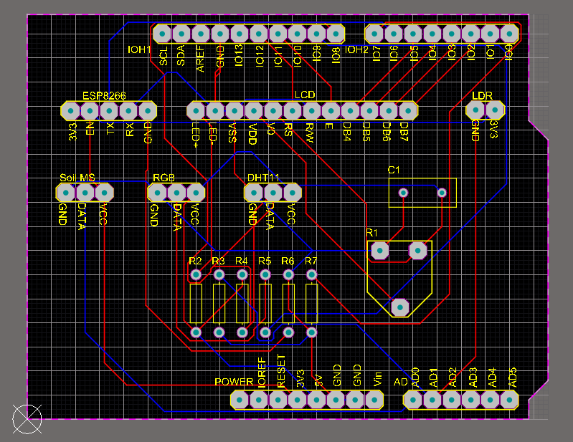
13.3 PCB & Schematic
13.4 Bill of Materials
Here is the Bill of materials for every component in the IoT project. The prices are to the nearest I could find. The unit for the resistors is ohms (Ω) and the capacitor is in uF. The PCB is of my own design and was ordered online, I received 5 but only used one in the project. The various wire packs include male to female, male to male and female to female. The total price does not consider the physical build of the project, the adhesives or the tools in which were used to make the project.
Component | Quantity | Cost in €
DHT11 | x1 | 2.00
LCD | x1 | 10.00
RGB strip (30 LEDs) | x1 | 10.00
LDR | x1 | 1.00
Soil moisture sensor | x1 | 4.00
Peristaltic pump | x1 | 15.00
3V Motor | x1 | 3.00
ESP8266 | x1 | 3.00
1.8k Resistor | x1 | 0.20
3.3k Resistor | x1 | 0.20
10k Resistor | x2 | 0.20 x2
220 Resistor | x2 | 0.20 x2
470 Resistor | x1 | 0.20
100 uF Capacitor | x1 | 2.00
10k Potentiometer | x1 | 2.00
ULN2003 | x2 | 0.70 x2
Arduino Uno | x2 | 25.00 x2
PCB | x1 | 2.00
3V Power pack | x1(2 AA batteries) | 4.00
Various wire packs | x5(10 wires) | 3.50 x5
Velcro heavy duty | x1(roll) | 8.00
Breadboard | x1 | 4.00
Stripboard | x1 | 3.00
12V wall adapter | x1 | 5.00
Single core cable | x1(spool) | 12.00
Shrink-wrap | x1(pack) | 4.00
 |  | Total:164.30

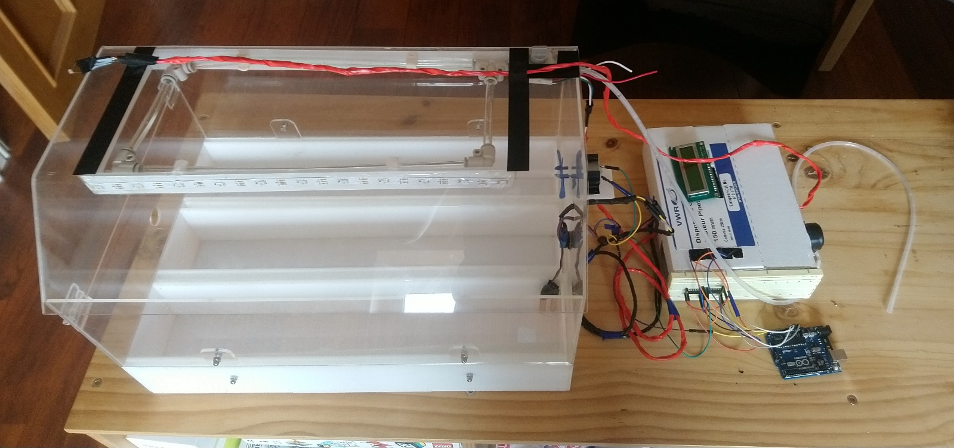
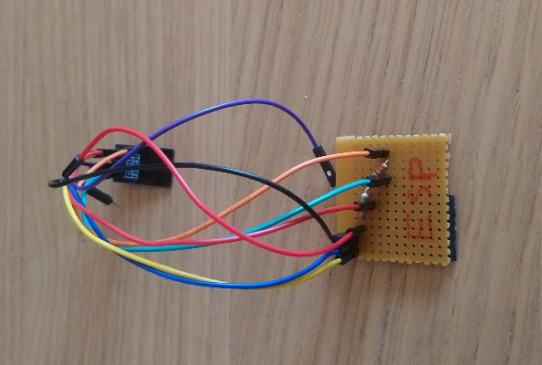
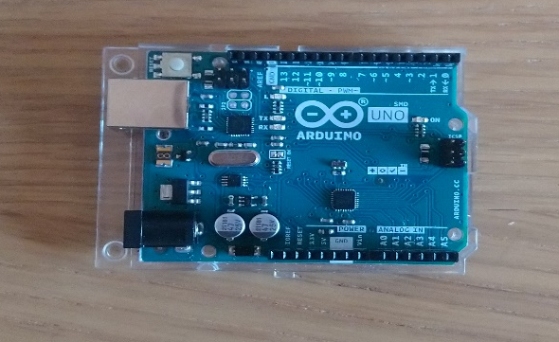
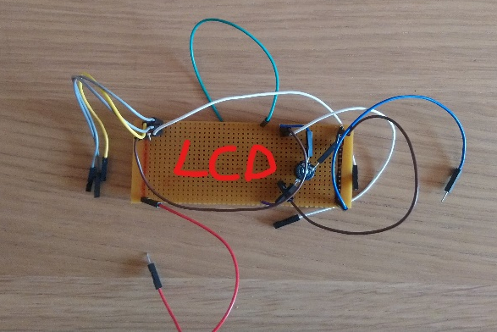
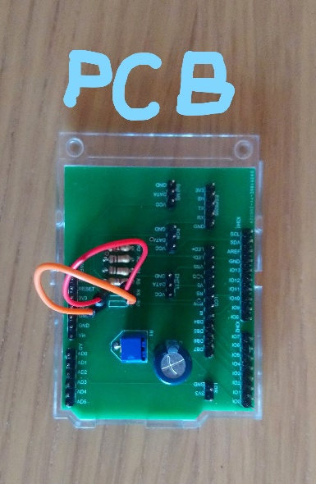
13.5 Final Pictures of Project
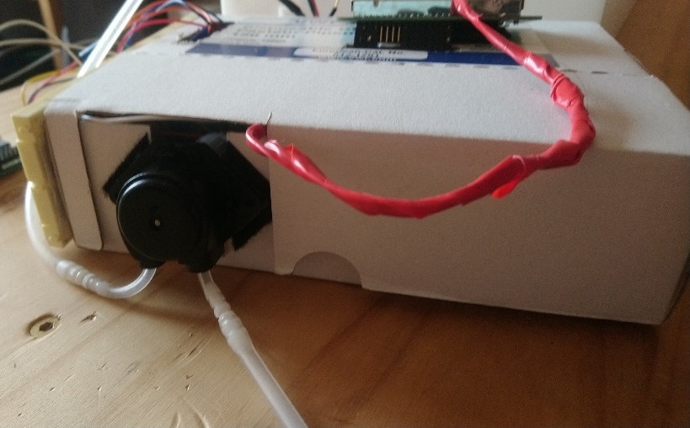
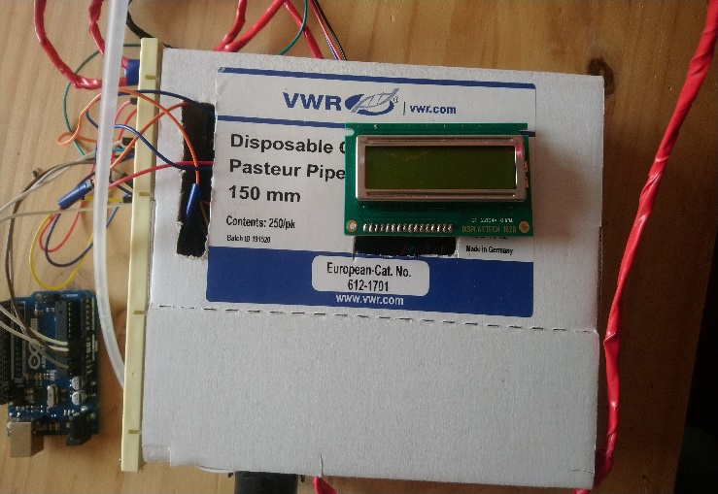
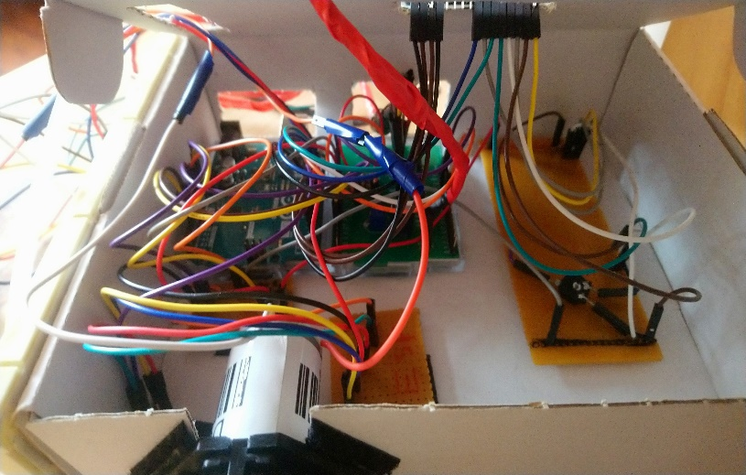
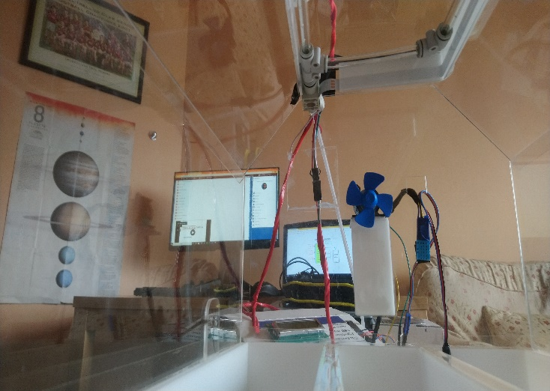
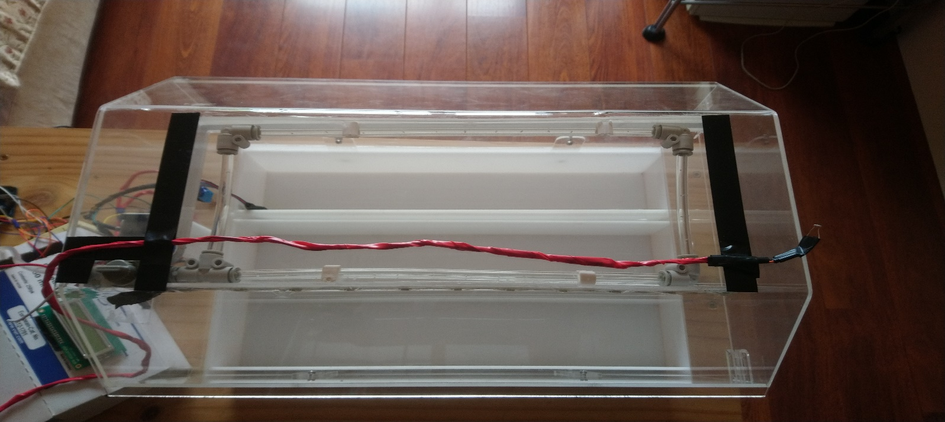

13.6 Drawings of Manufacture
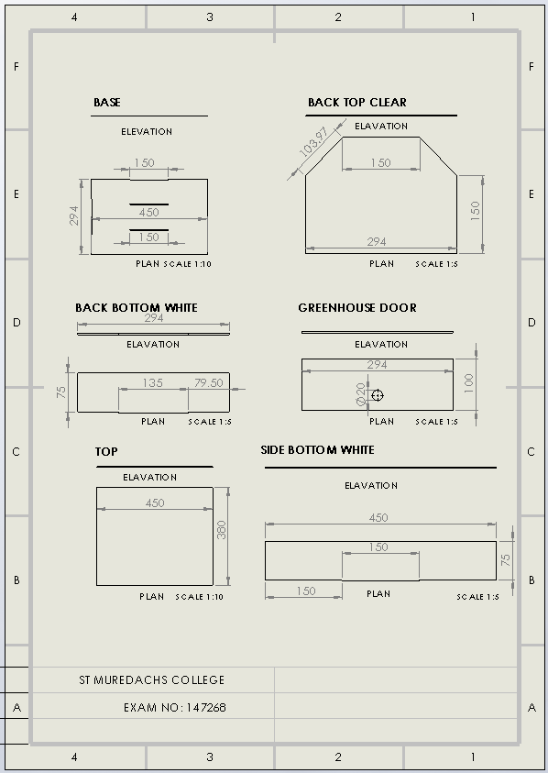
These are some drawings of manufacture which are from my Solidworks project from my leaving Certificate. This allows people to view the exact measurements of the physical side of the greenhouse:


